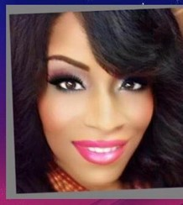[Rumburak Regular](https://www.1001fonts.com/rumburak-font.html)[Amagh Demo](https://www.1001fonts.com/amagh-font.html)

**Carol A. Lunkins, MBA**

MOTIVATIONAL SPEAKER PASTOR STRATEGIC COACH

Pastor Carol Love’ Lunkins is the Founder and CEO of the Woman of Wisdom (WOW) Ministries, which is a nationwide Nonprofit Organization. WOW was established in 2008 to Empower, Enlighten, Enhance, and Encourage women of all ethnicities.

Pastor Carol is an ordained, non-denominational Pastor and Evangelist with immense certifications in biblical studies. She also holds an MBA in Organizational Leadership and a Bachelor’s Degree in Information Systems. She works in leadership for the U.S. Government with over 30 years of expertise. She is a certified trainer, Lean Six Sigma Green Belt, project manager, and graduate of the Federal Government’s Advanced Leadership Program.

As well, Carol is an entrepreneur, strategic coach, event coordinator, and writer. She is an affiliate of the National Women’s Leadership Association (NETWORK) and Global Pastor’s Association. Pastor Carol is a native of Chicago, Illinois. She hosts a weekly nationwide Teleconference Inspirational Service, where women are being transformed, healed, delivered, and provided with tools to live their best life now.

Her philanthropic efforts include support for Breast Cancer research, career awareness, along with mitigation of homelessness, illiteracy, and domestic violence.